MGE30301 Assignment #2

Principal Component Analysis

- PCA On Breast Cancer Dataset -

March 2018

Undergraduate School of Natural Science
UNIST
Mathematical Science Major

20121229 Jun Pyo Park

Access to Data and Processing
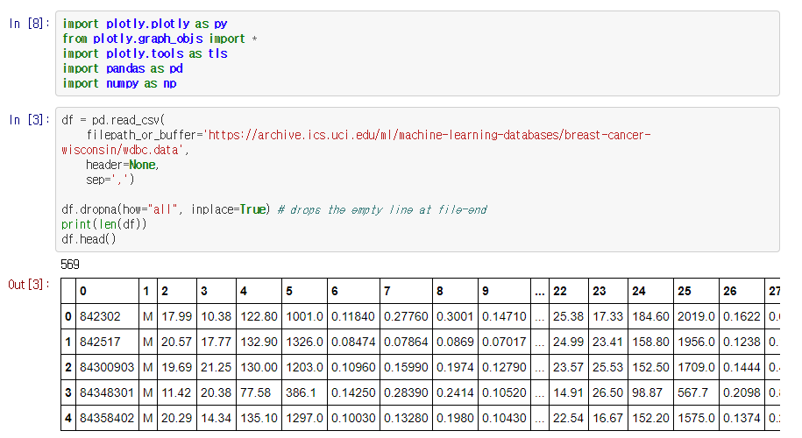

Data Description

Number of instances: 569
Number of attributes: 32 (ID, diagnosis, 30 real-valued input features
Attribute information

1) ID number
2) Diagnosis (M = malignant, B = benign)
3-32)

Ten real-valued features are computed for each cell nucleus:

a) radius (mean of distances from center to points on the perimeter)
b) texture (standard deviation of gray-scale values)
c) perimeter
d) area
e) smoothness (local variation in radius lengths)
f) compactness (perimeter^2 / area - 1.0)
g) concavity (severity of concave portions of the contour)
h) concave points (number of concave portions of the contour)
i) symmetry
j) fractal dimension ("coastline approximation" - 1)

PCA Process

Standardizing

Calculating Covariance Matrix

Get Eigen Decomposition

Check Orthogonality

Check the cumulative explained variance in order

Calculating PC Score

Jupyter Notebook File Github Link : goo.gl/mfRwWX

Results

Eigen Values & Eigen Vectors
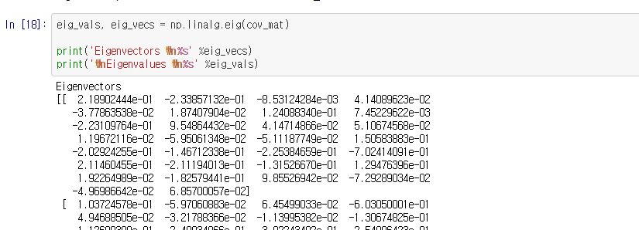
…
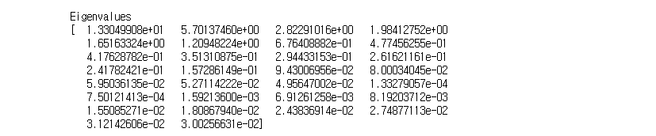

Cumulative % of Variance
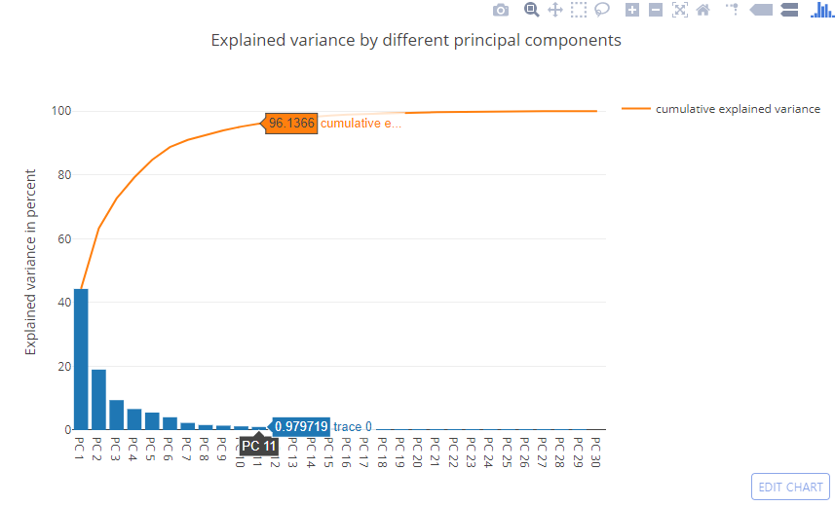
This figure shows that the most of the variance(95.15%) can be explained by the first 10 principal components.

PC Scores
